Aizome Workshop
September 29th, 2018
1) "What is Aizome? ", Presentation by Dede Shine (Mashiko International Exchange Association)
2) Aizome Workshop by Kay Yamakawa (Mashiko International Exchange Association)

Group A, and B (A Group : A =>B =>C , B Group : B => A => C )

A. Cotton Handkerchiefs by Discharge of Aizome Dye
- Select your design from Dye Stencils.
- Put the fabric over the board: 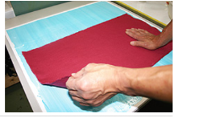
- Put the Dye Stencils over the fabric
- Smear Discharge on Dye Stencil : 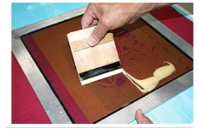
- Take out Dye Stencil and Dry
- Iron 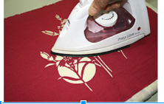
- Wash/rinse by water in the sink

B. Cotton Gauze Scarves - 15" X 60" by Wood Binding Dye.
Learn the Japanese traditional design: leaf of hemp 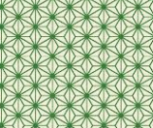

1、 Fold as /\/\
2、 Make triangle at center
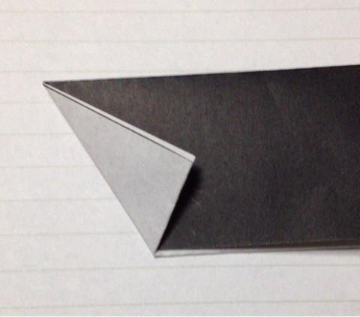

3、Back
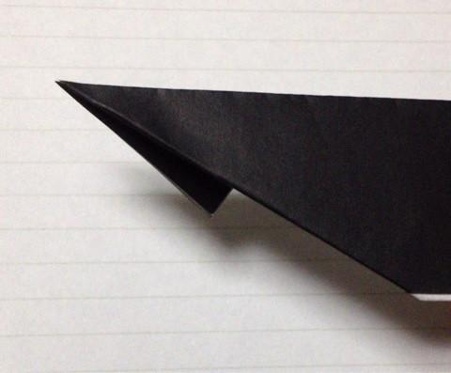

4、 Fold
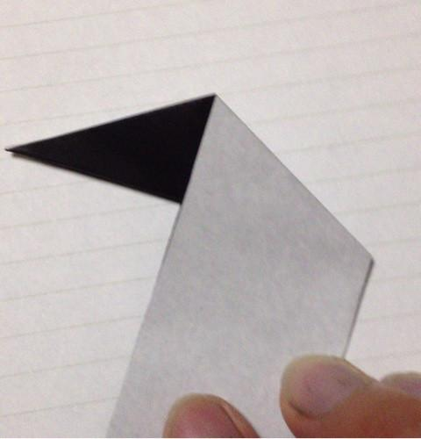
5、Fold along to edge
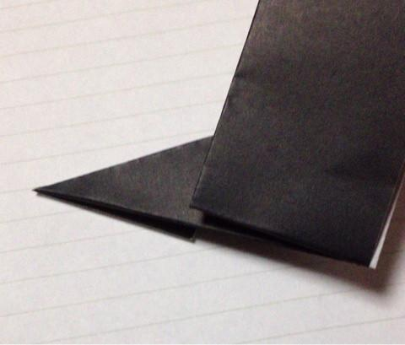
6、Fold back to the right side
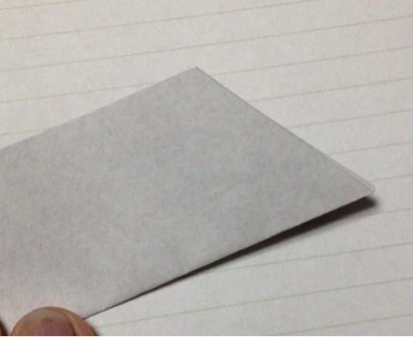
7、Fold back as along to long edge of Isosceles
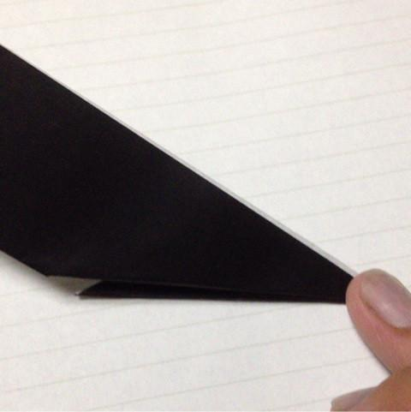
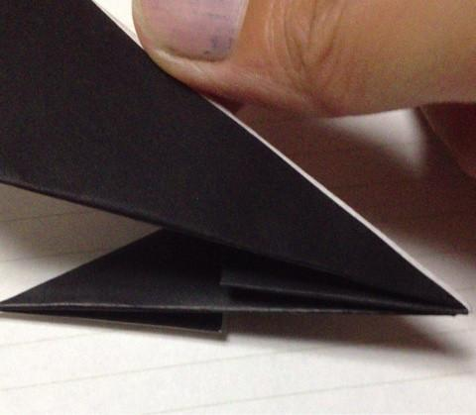
8、Fold at center
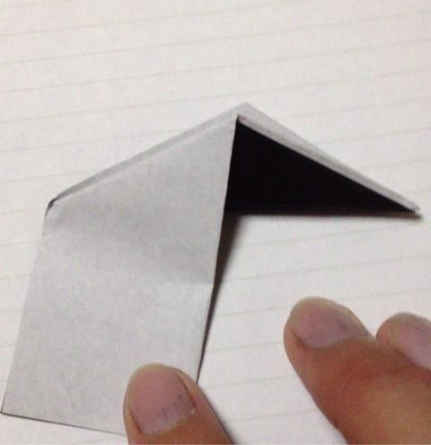
same ways
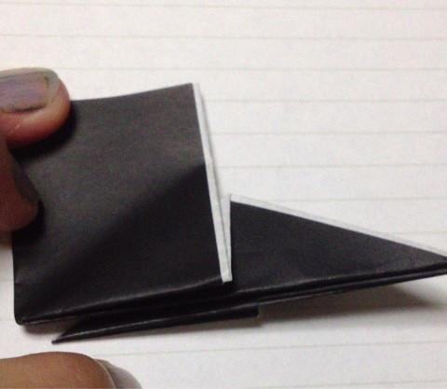

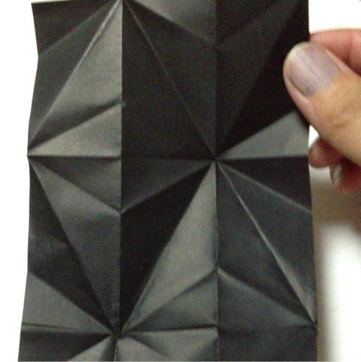

Wood Binding Dye 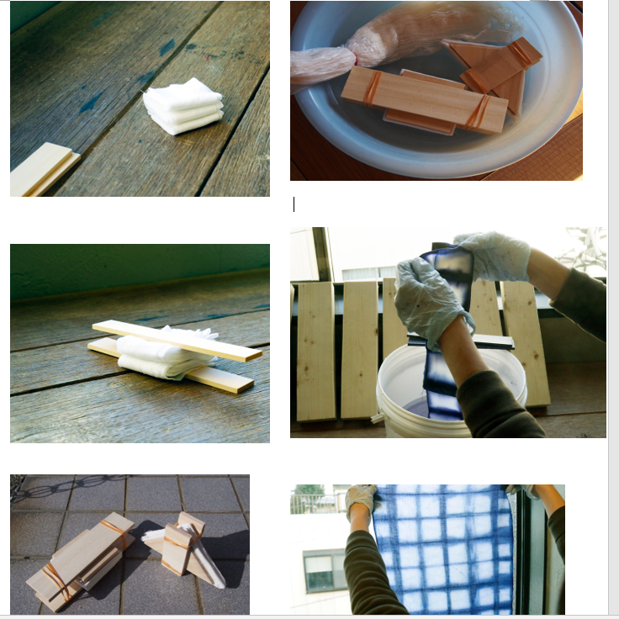

C.T-shirt
You can pick Wood Binding Dyeing, Tie-Dyeing, Resist Dyeing, Shibori Dyeing, Gradient Dyeing or others..

Reference:
Dharma Trading Co. (800) 542-5227 or (707) 283-0390 www.dharmatrading.com
- Pre-Reduced Indigo Crystals - 8 oz.
- Soda Ash Fixer
- Sodium Hydrosulfite

