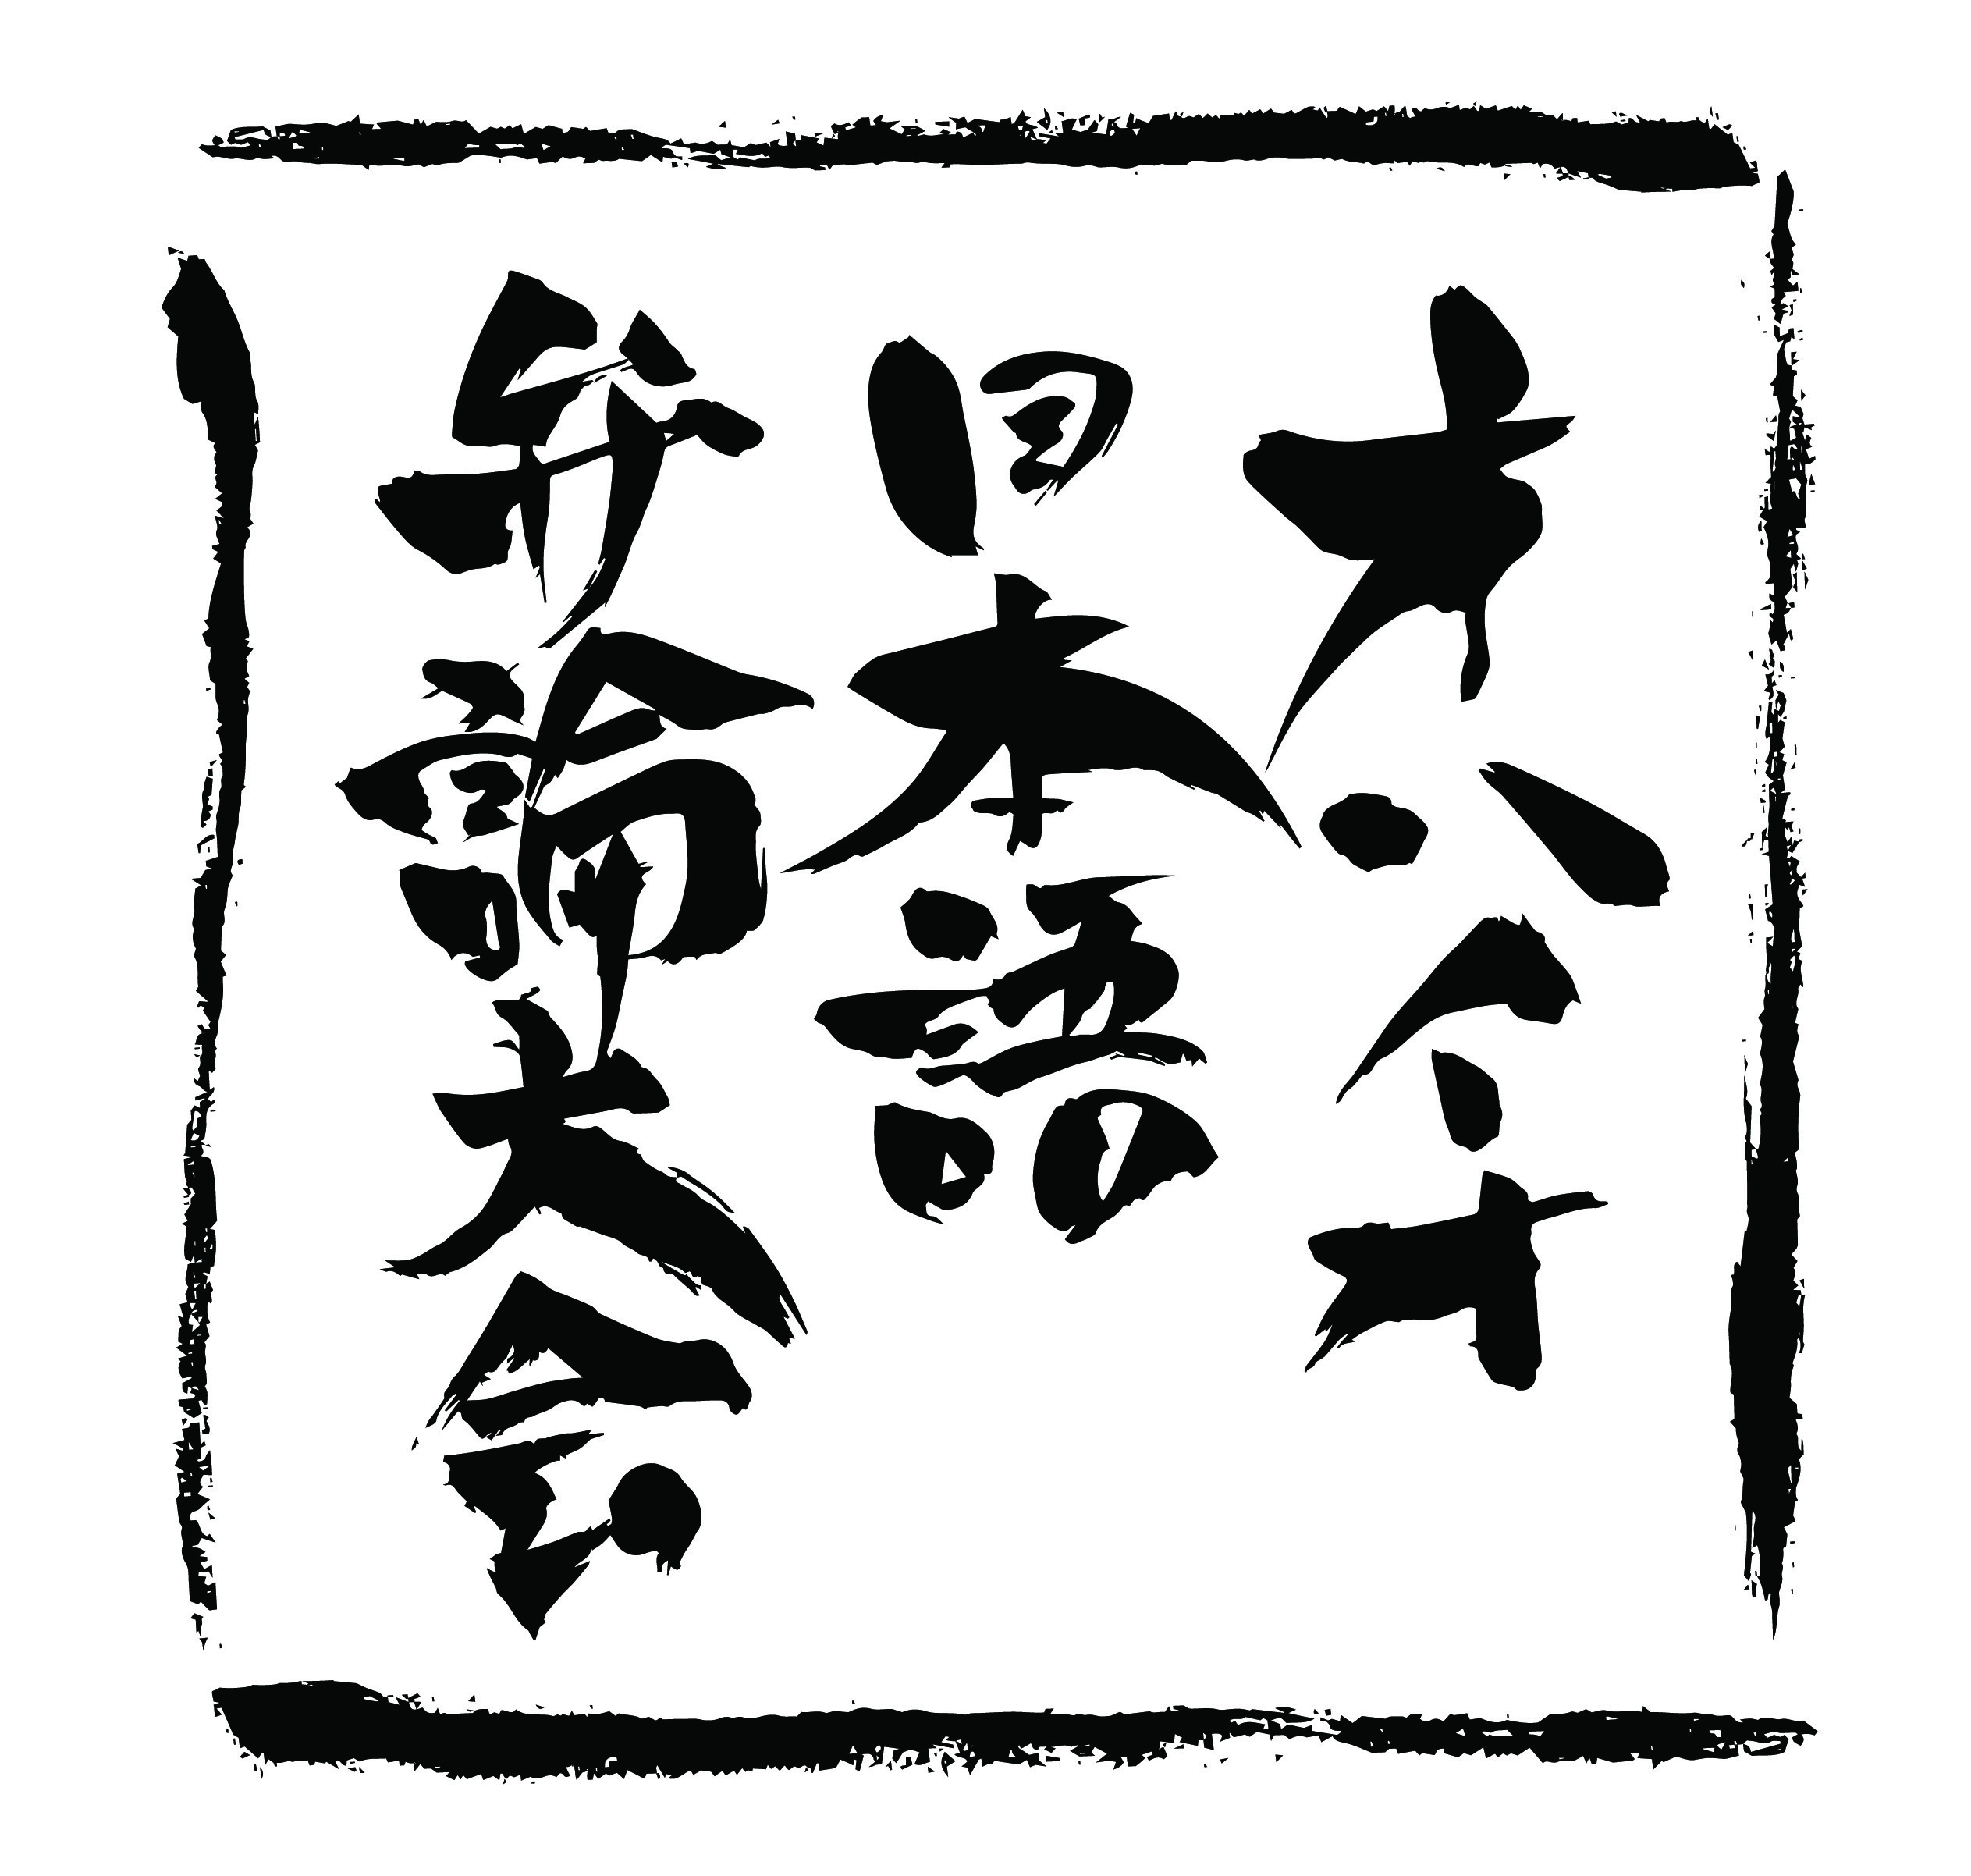 | Ohio Japanese Speech Contest  2022 Application Form
Name
Address
City | State | ZIP
Phone | Age | Gender
E-Mail

- Speech Title (in Japanese)
- Speech Title (in English)

Eligibility
By applying to the Ohio Japanese Speech Contest, you are confirming that you:
- Will be 15 years or older at the time of the finals
- Have learned to speak Japanese through an intentional study
- Have lived in the state of Ohio for at least 24 months, although not necessarily consecutively
- Will participate in the finals virtually via Zoom
- Agree to have your speech recorded and distributed on social media at JASCO’s discretion

By typing my name below, I certify that the above information is true and the speech, written and spoken, is my own original work.
Signature: Date:

- Additional Participant Information
- (The information in this box will not affect the judging for the contest.)
- How long have you been studying the Japanese language? ______________________________________
Have you participated in previous Ohio Japanese Language Speech Contests? Yes No
If yes, what year(s)? ___________________
Have you won any prizes in those previous years? Yes No
If yes, What prize? _______________________________________________
If you are currently studying Japanese in a program (e.g., high school, college, community program), please indicate:
Your program/school name - _____________________________________________________________
Your instructor’s name - _________________________________________________________________
Your instructor’s e-mail - ________________________________________________________________

Please submit the following 3 items by email to the Japan-America Society of Central Ohio at
jasco@jas-co.org:
- A completed Application Form
- A short synopsis of your speech content in Japanese
  - Handwritten or typed; Genkō yōshi formatting is not required.
- An audio recording of the synopsis (no more than 3 minutes long)
Applicants may submit the speech script instead of the synopsis if they wish.
If selected as a finalist, applicants must submit a full speech script along with English translation by March 12th, 2022.
Applications must be received by the JASCO office by Friday, February 25, 2022 at 11:59pm.
Late applications will not be considered.

Read the Ohio Japanese Language Speech Contest Handbook or visit
https://www.jas-co.org/ohiojapanesespeechcontest for more detailed information and guidelines. For questions, contact JASCO at jasco@jas-co.org.

